**Financial Engineering Lab MA – 374 Lab – 9**

**Name –** Rasesh Srivastava

**Roll Number –** 210123072

**Branch –** Mathematics and Computing

Question 1:

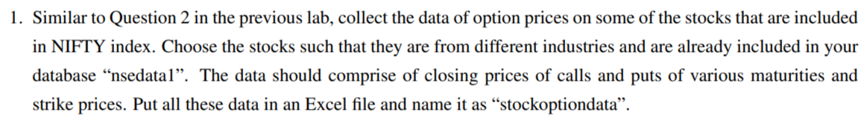

Data for following companies (from nsedata1) are taken for the analysis:

1. Bajaj-Auto

2. Reliance

3. HDFC Bank

4. Hero Motor Corp.

5. Tata Motors

6. NSE Index (NIFTY 50)

Question 2:

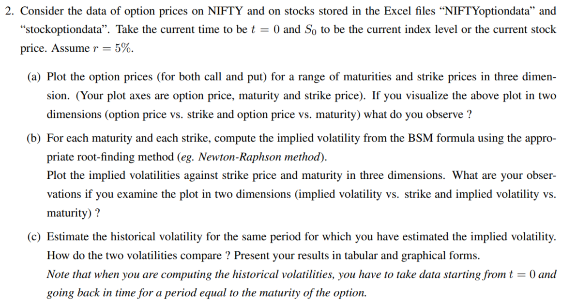

a)

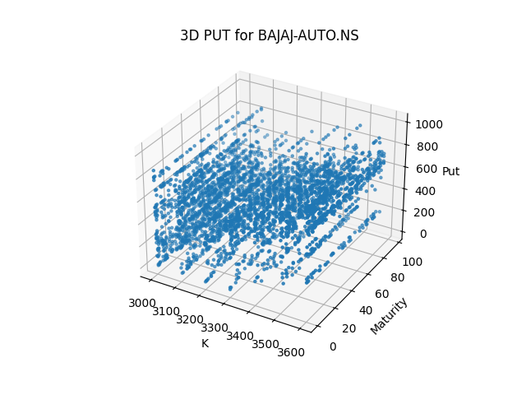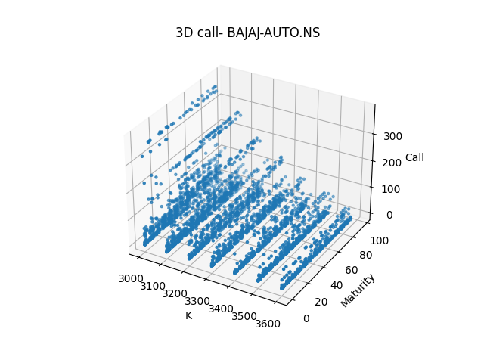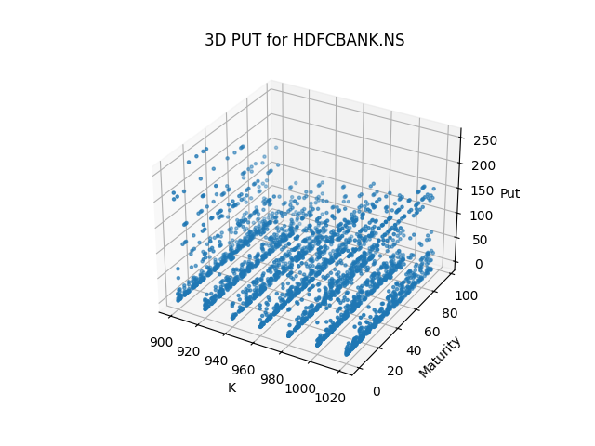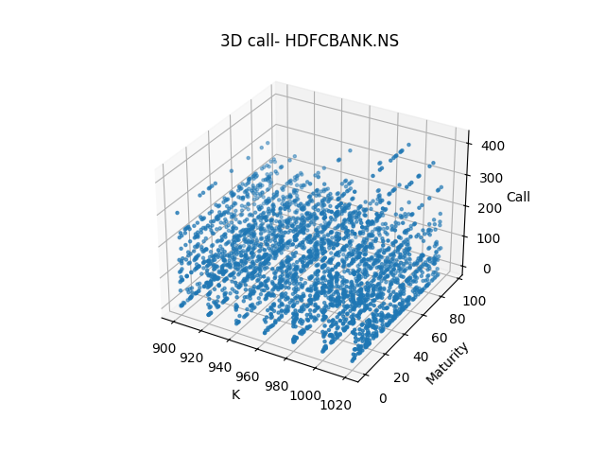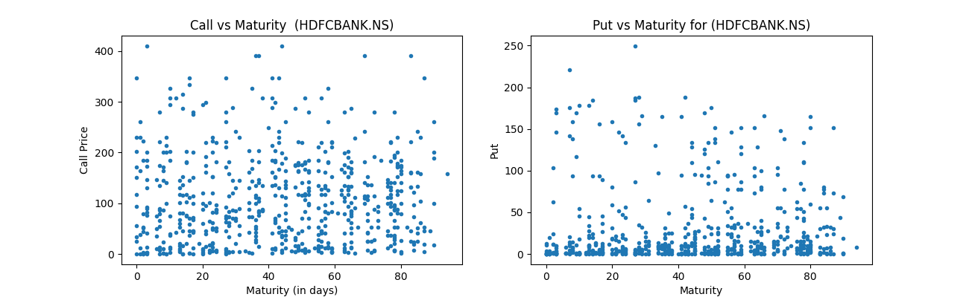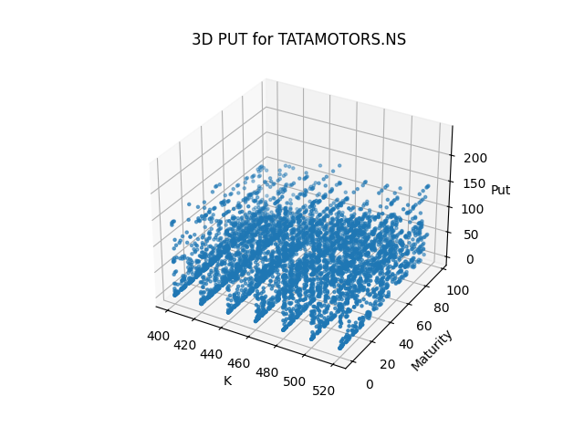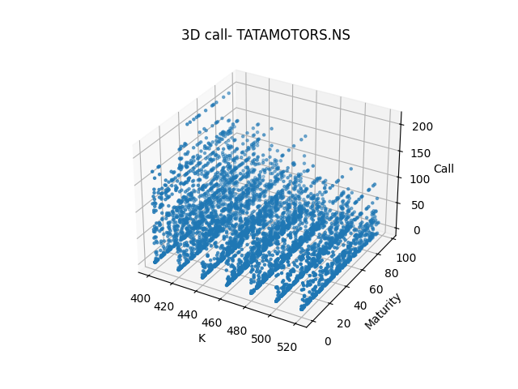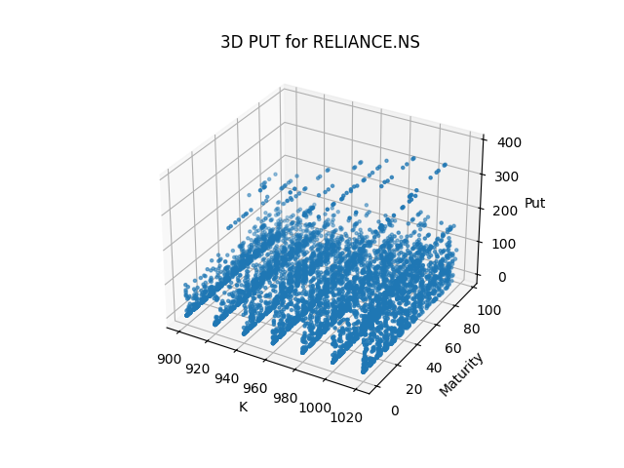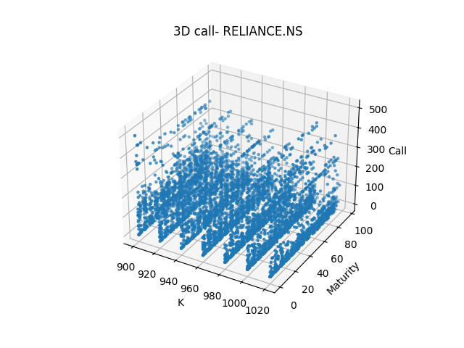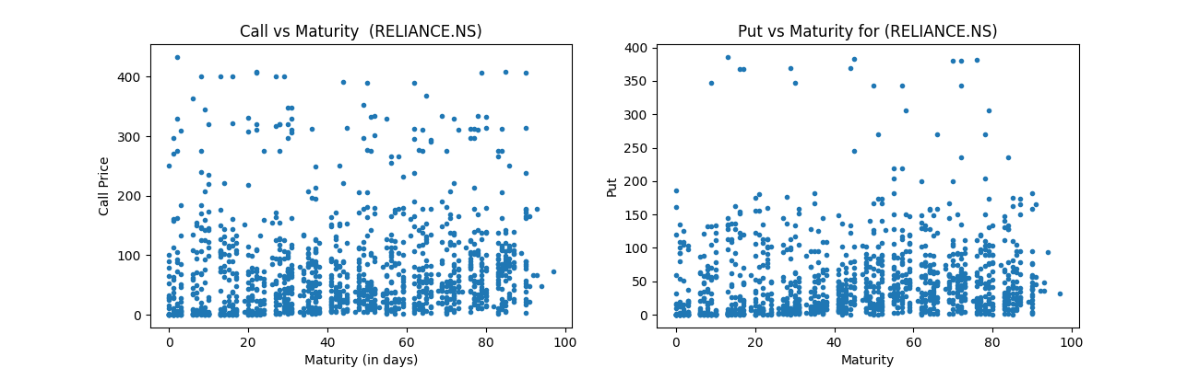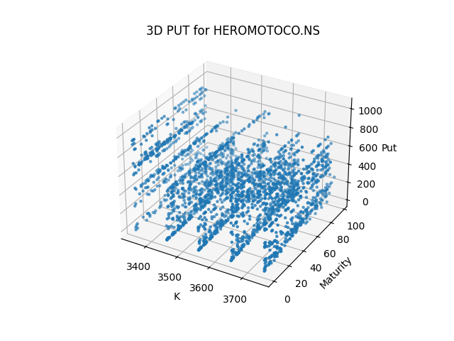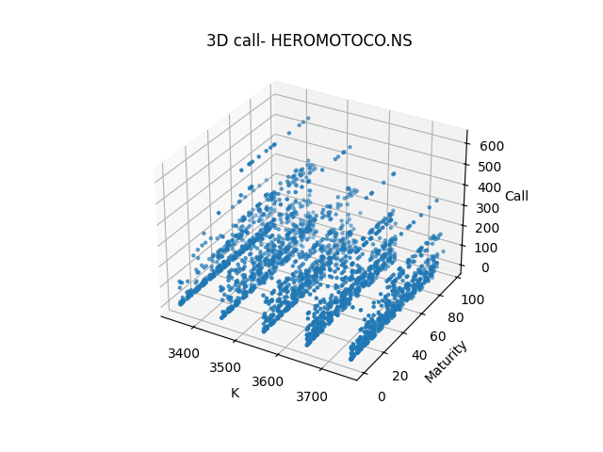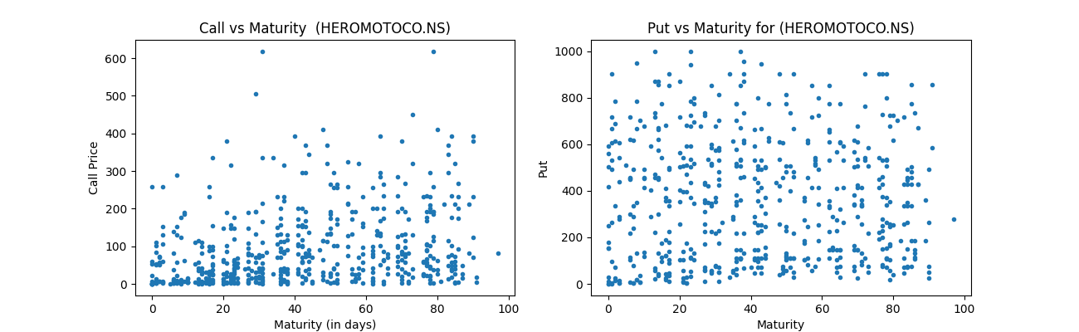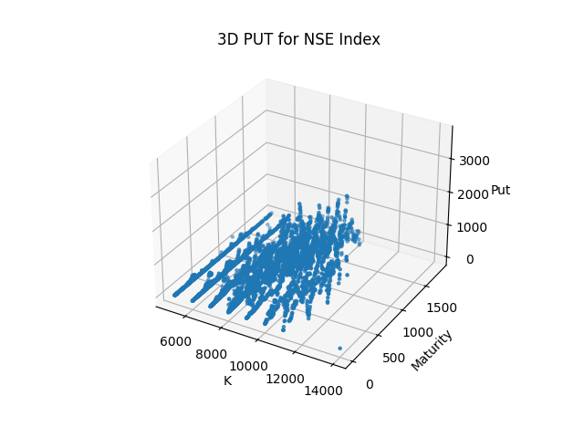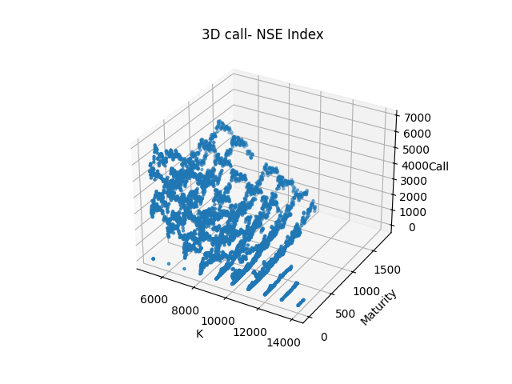

b)

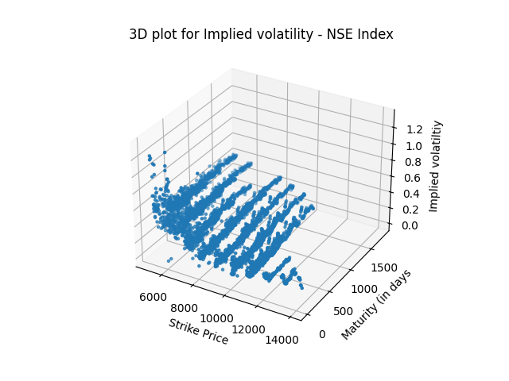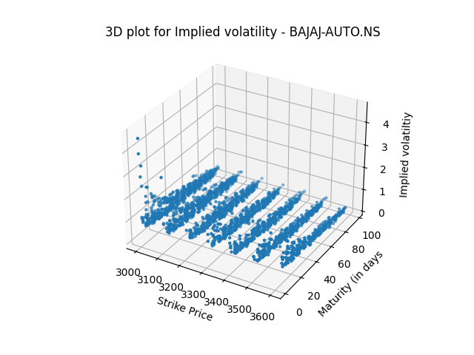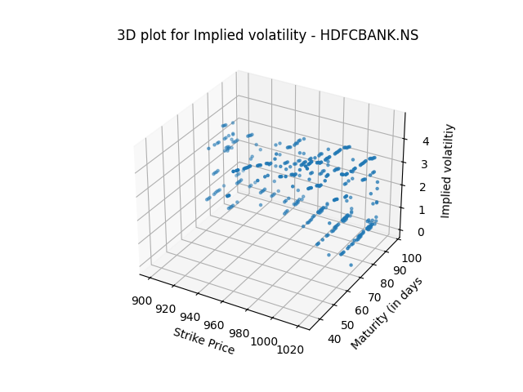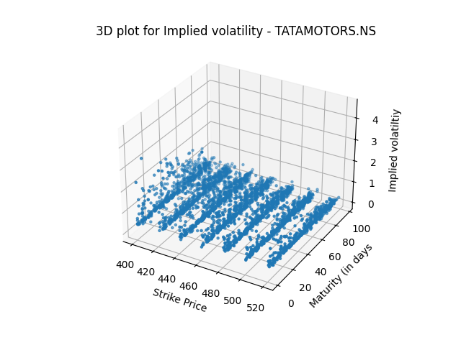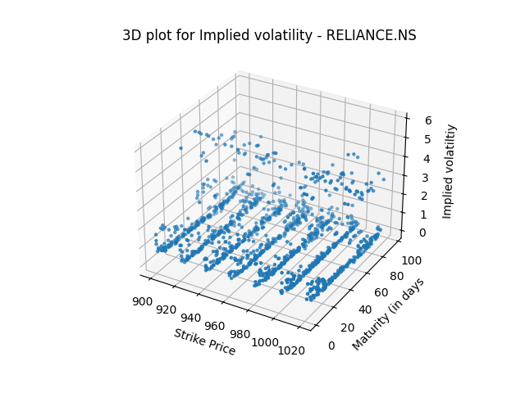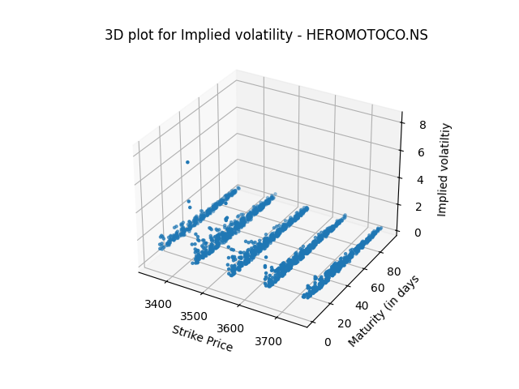

c)

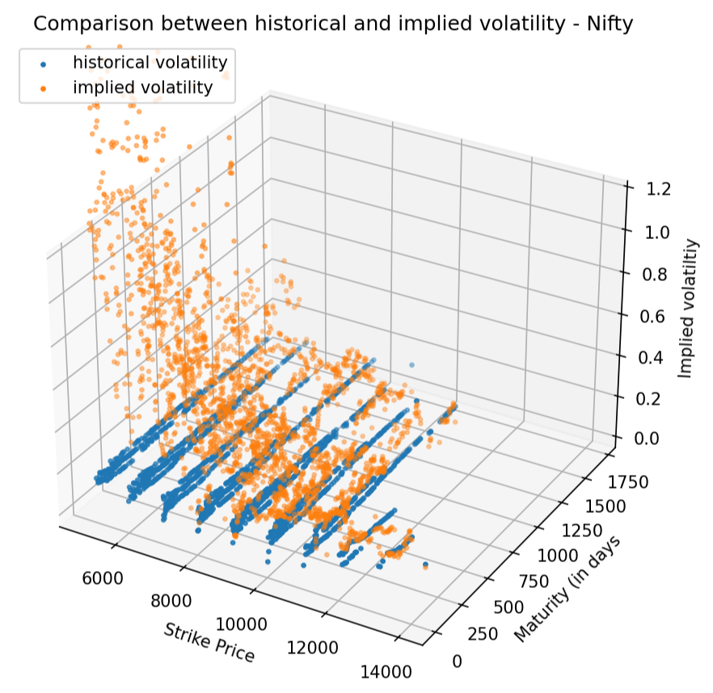

The tabular data is as follows:

The tabular data is as follows:

The tabular data is as follows:

**Observations:**

1. We can observe that the price of call option decreases and that of put option increases with an increase in strike price. This trend is within our expectations.
2. But the plot for call option and put option doesn’t exactly match with our expectations. The general trend is that the price of call option tends to increase while that of put option tends to decrease with an increase in maturity period.
3. The lack of sufficient data adds difficulty in making proper analysis, but general trends can be figured out by considering the plots for NIFTY50 since it has larger data-points. The other plots also show similar trends.
4. Theoretically, the implied volatility is generally a convex function of strike price, and the curve so formed is known as the Volatility Smile. But this feature is not prominently observed in the plotted curves.
5. The volatility generally tends to decrease for larger maturity values, but for some of the above plots this nature is not very much observed.
6. Historical volatility is an estimate of the volatility over the past period, while the implied volatility is the estimation of the volatility for the upcoming months.
7. For data of some of the stocks like NIFTY50 and RELIANCE, implied volatility is generally higher while for stocks like BAJAJ-AUTO and TATAMOTORS, historical volatility is generally higher than the implied volatility. The significant difference between these 2 values arises due to several factors present in real market.
8. The plot for historical vs implied volatility very well captures this relation. Other plots show the dependence of different types of volatility with varying strike price and maturity.
9. Apart from the strike price and maturity period, the implied volatility and the option value also seems to also depend on when the price was collected. This means that even if the period values are same, the prices may differ if they are collected at different point of time. This is because the real market has several other random components, which affect the prices. Owing to this reason, the scatter plots are constructed to capture all these factors.